Contents
Background 1
Create Company Holiday Schemes 1
Extend Company Holiday Schemes 3

Background

A Holiday Scheme is a list of closure dates, such as public/bank holidays and departmental fixed closure days. These dates will be treated as non-working days for anyone linked to the Holiday Scheme (via their Balance). The system using employee work schedules to determine if the employee would normally work on the closure day and adjusts their entitlement accordingly.

A Holiday scheme can be linked to a Balance, but this is optional and Balances will function without a Holiday Scheme. Holiday Schemes should not be used with Accrual Balances.

A single Holiday Scheme can be linked to multiple Balances with:

- Different FTE Hours
- Different Long Service Schemes
- Different leave years
- Different Base Entitlement
All Balances linked to a Holiday Scheme must share the same:

- Mandatory holiday dates (e.g. public holiday and fixed closure dates)

To complete this function menu profile WFM_BANK_HOLIDAY_CONFIG must be assigned to the individual portal user via Security > User Management.

Create Company Holiday Schemes

 | NB: To complete this process menu profile WFM_BANK-HOLIDAY_CONFIG is required.

- Login to PeopleXD

- Navigate to the WFM Admin Dashboard > WFM Configuration > Configuration Settings > Bank Holiday Schemes

- Check that the Holiday Scheme you intend to create isn’t already there.

- To create new click on the ‘Add New Scheme’ button.

- In the ‘Add New Holiday Scheme’ window, enter a code for your Holiday Scheme. This is a unique identifier for the scheme, but won’t be seen by HR Admins/end users. Maximum number of characters for the code is ‘.

- Enter a Description (Maximum 40 characters). This will help HR System users manage the scheme and link it to a Balance, but won’t be seen by HR Admins/end users.

- Click OK to save the record.

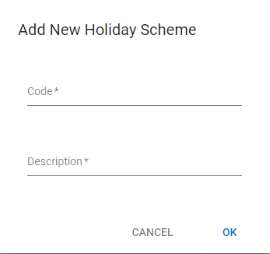

- The Holiday Scheme details screen opens for the scheme you have just created. Ensure you are on the General Settings tab. (This is the only tab which currently needs to be completed for the University configuration.)

- Click on Add to enter the scheme closure date. You will need to repeat this to add each separate closure day until you build up all closure dates for that scheme. Each row represents a closure day.

- Complete the following fields for each closure day:

Field | Description
Holiday Date | Enter/select the required date
Pay Code | Enter/select one of the following pay codes:  ‘160 – PUBLIC HOLIDAY’ for all bank/public holidays (e.g. Easter Monday)  ‘3990 – FIXED CLOSURE DAY’ for all departmental closure days, (e.g. the days between Christmas and New Year).
Hours | Select ‘Calculate’ from the drop down listing.
Apply Hours | Leave as the default ‘ALL’.

- SAVE.

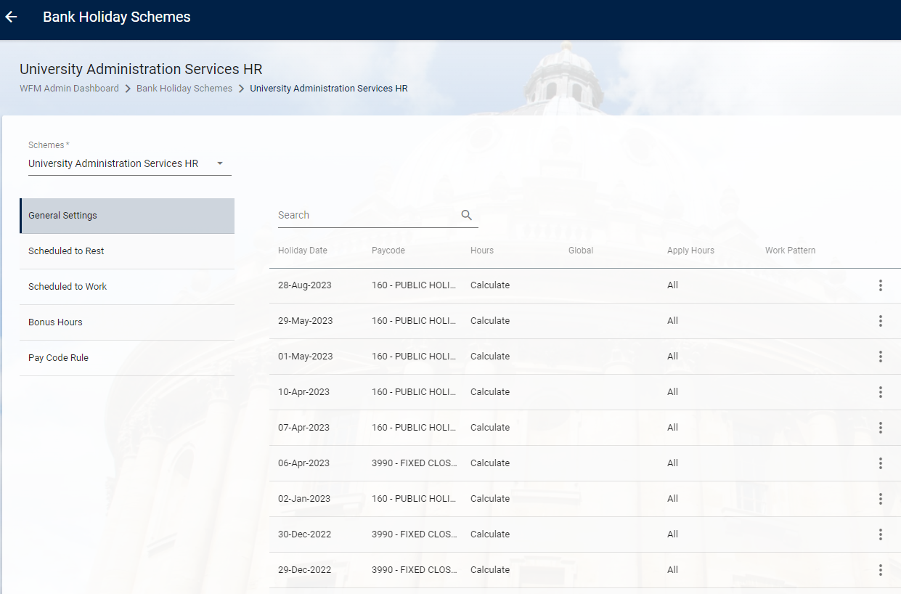

Extend Company Holiday Schemes

- Login to PeopleXD

- Navigate to the WFM Admin Dashboard > WFM Configuration > Configuration Settings > Bank Holiday Schemes

- Locate the Holiday Scheme you intend to extend.

- Click on the 3 dots ellipses and select View.

- The Holiday Scheme details screen opens for the scheme you have just selected. Ensure you are on the General Settings tab. (This is the only tab which currently needs to be completed for the University configuration.)

- Click on Add to enter the extended scheme closure dates. You will need to repeat this to add each separate closure day until you build up all closure dates for that scheme. Each row represents a closure day.

- Complete the following fields for each closure day:

Field | Description
Holiday Date | Enter/select the required date
Pay Code | Enter/select one of the following pay codes:  ‘160 – PUBLIC HOLIDAY’ for all bank/public holidays (e.g. Easter Monday)  ‘3990 – FIXED CLOSURE DAY’ for all departmental closure days, (e.g. the days between Christmas and New Year).
Hours | Select ‘Calculate’ from the drop down listing.
Apply Hours | Leave as the default ‘ALL’.

- SAVE.

